Lab 1.5:

Exercise 1: Console output

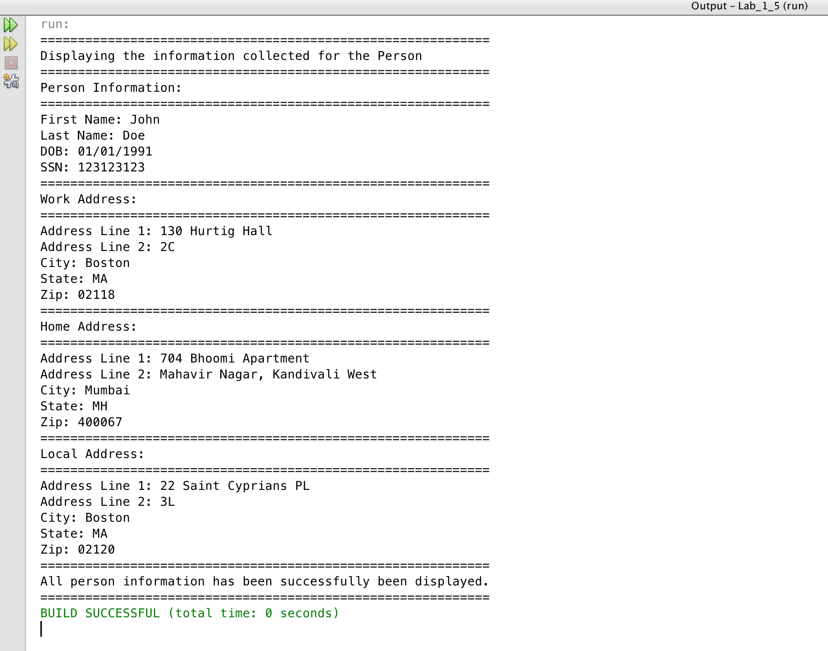

Exercise 2: View Screen

